**Guide to Creating an Agent Through Chat**



**Two Ways to Create an Agent in the System**

The system offers two main methods for creating a new agent, allowing adaptation to different needs and complexity levels:

* **Creating an agent using the Add New Agent button –** Quick agent creation with a button click through the chat, by filling out basic fields only. This option is suitable for cases where you need to set up an agent quickly without complex configurations.
* **Creating an agent using the Interactive interface –** Creating an agent in a dedicated screen where you can define the agent's characteristics in detail, including prompts, rules, and advanced settings. This option is particularly suitable for cases requiring extensive customization of the agent, or when working with organizational data.

## **Creating an Agent Using the Add New Agent Button**

To create an agent in a simplified way, go to the Chat tab and click the Add New Agent button.

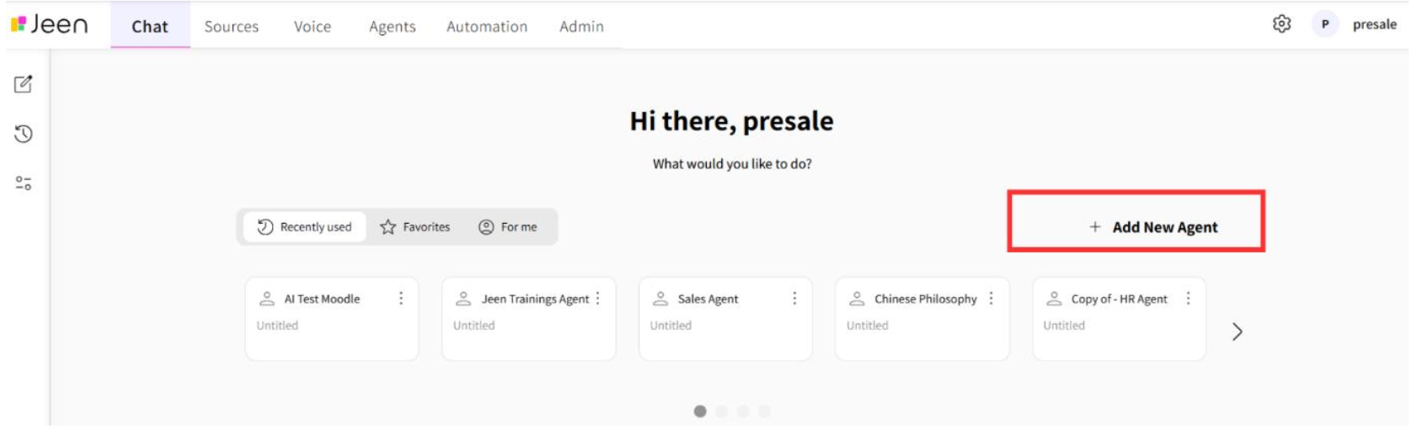

Then, fill in the agent's name, add a brief one-sentence description of the agent's role or area of activity, and a more detailed description of the agent containing the agent's main purpose, how it will assist users, and what tasks it will automate.

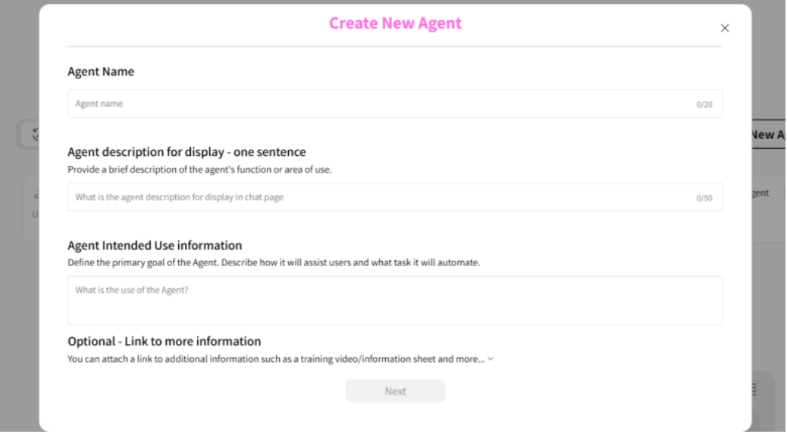

After completing all the details, we can click the Next button to continue creating the agent.

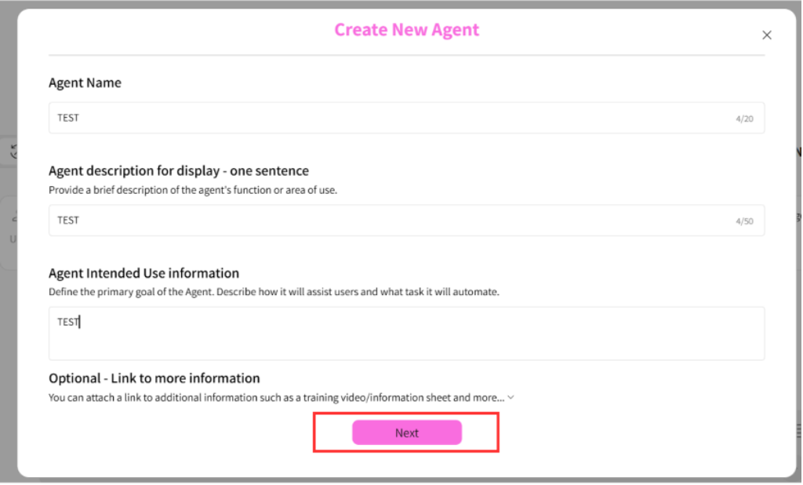

If we want to create an agent based on existing documents in Sources, we'll select the documents we want to appear in the agent.

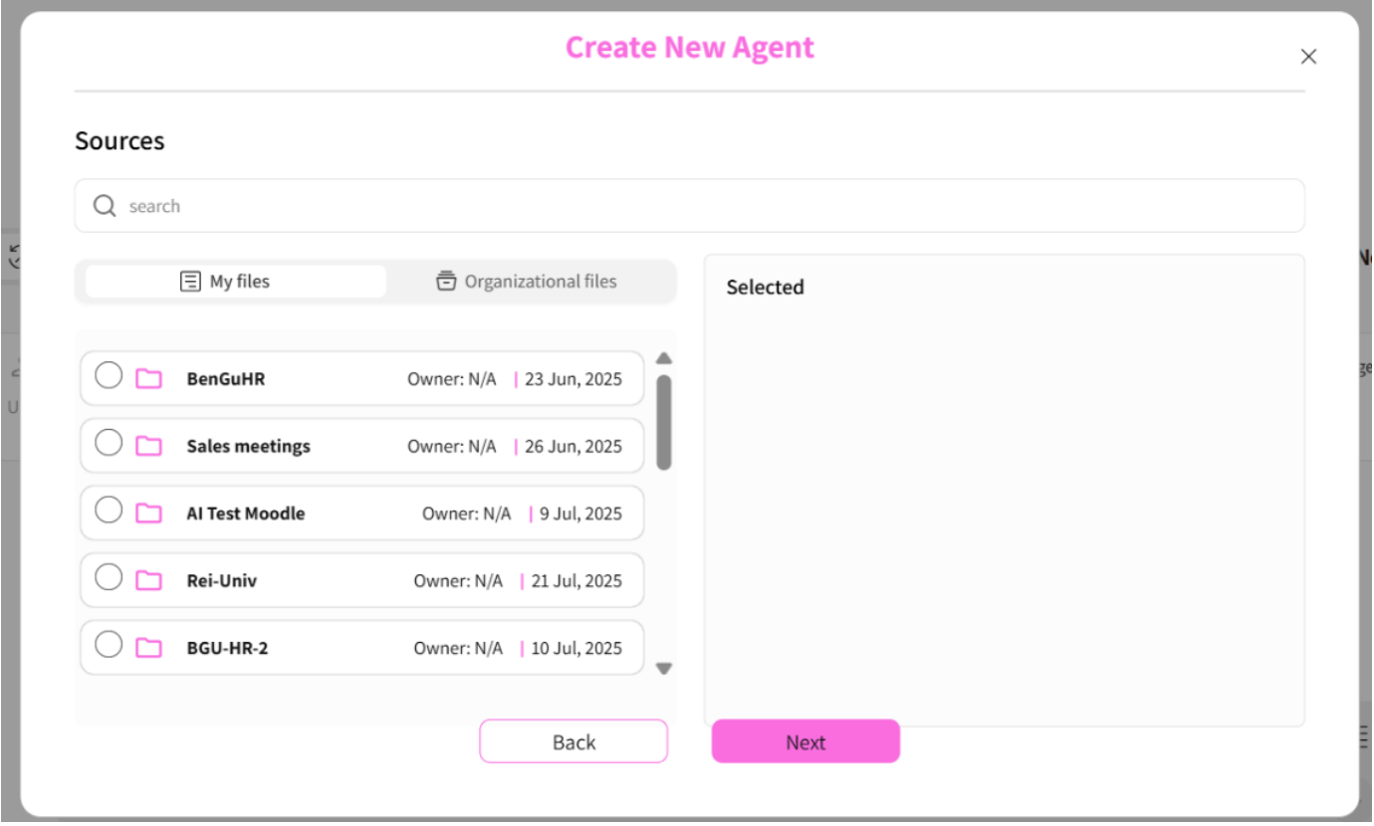

Click the Next button and we'll reach a screen where we need to choose whether we want to create an agent based on a prompt that we'll customize for our agent, or based on a pre-made template.

If we don't want to add documents, we can click the NEXT button and create an agent without documents.

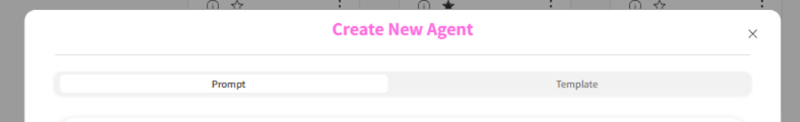

## 

## 

## 

## **Creating a Prompt-Based Agent**

A prompt is an instruction to the model on how to operate. The instruction can include a role (complex systems architect, senior programmer, senior position recruiter), instructions and tasks to perform, as well as a specific format in which we want the response to always be returned.

If we want to create an agent based on a prompt that we'll customize for the agent, we'll select the Prompt option and customize the prompt that appears for our agent's purpose. **It's recommended to only change the text written in asterisks.** Additionally, we'll select the model we'll use for the prompt. We'll choose the options we want to have in the conversation with the agent - chat and/or canvas. Then, we'll click Save.

### **When would we want to use a prompt?**

When we want to write the prompt ourselves and create an agent that's personally customized for specific purposes, or for documents we're attaching.

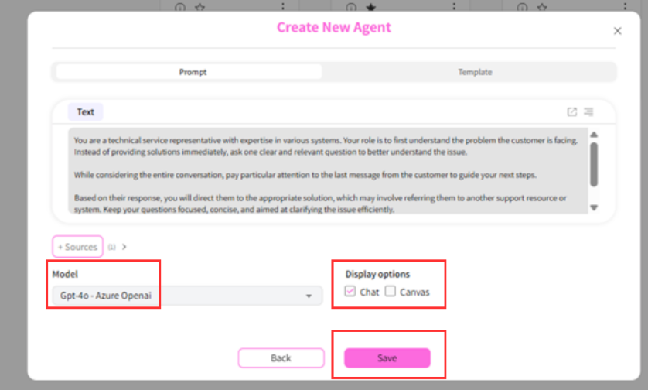

## **Creating a Template-Based Agent**

If we want to create an agent based on templates, we'll click the Template button.

We can search for the template we're interested in and read details about each template. After clicking the Save button, an agent will be created for us based on the documents we selected and the existing prompts in the template we chose.

### 

### 

### 

### **When would we use a template?**

When one of the templates is relevant for the documents and purposes I want to attach and create. When using a template, there's no need to write prompts. It can be suitable for more specific cases.

In this section as well, you can add documents by clicking the Sources button.

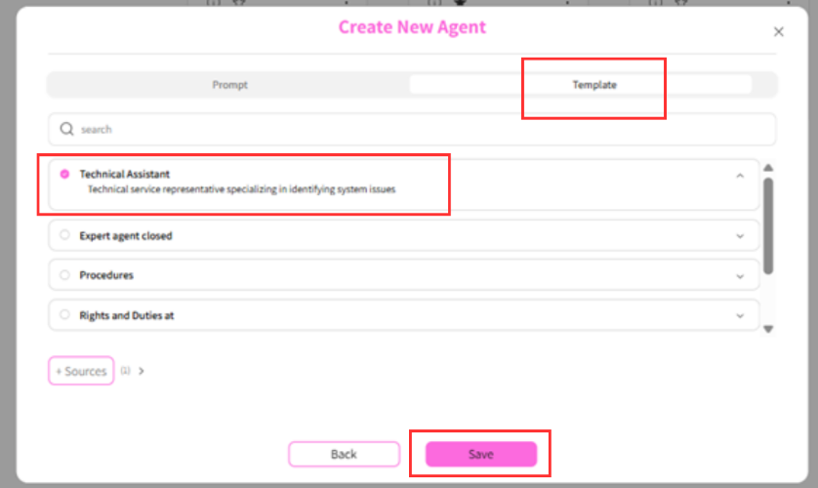

After clicking save, the agent is saved and appears in the agents carousel in the chat and in the Agents tab.

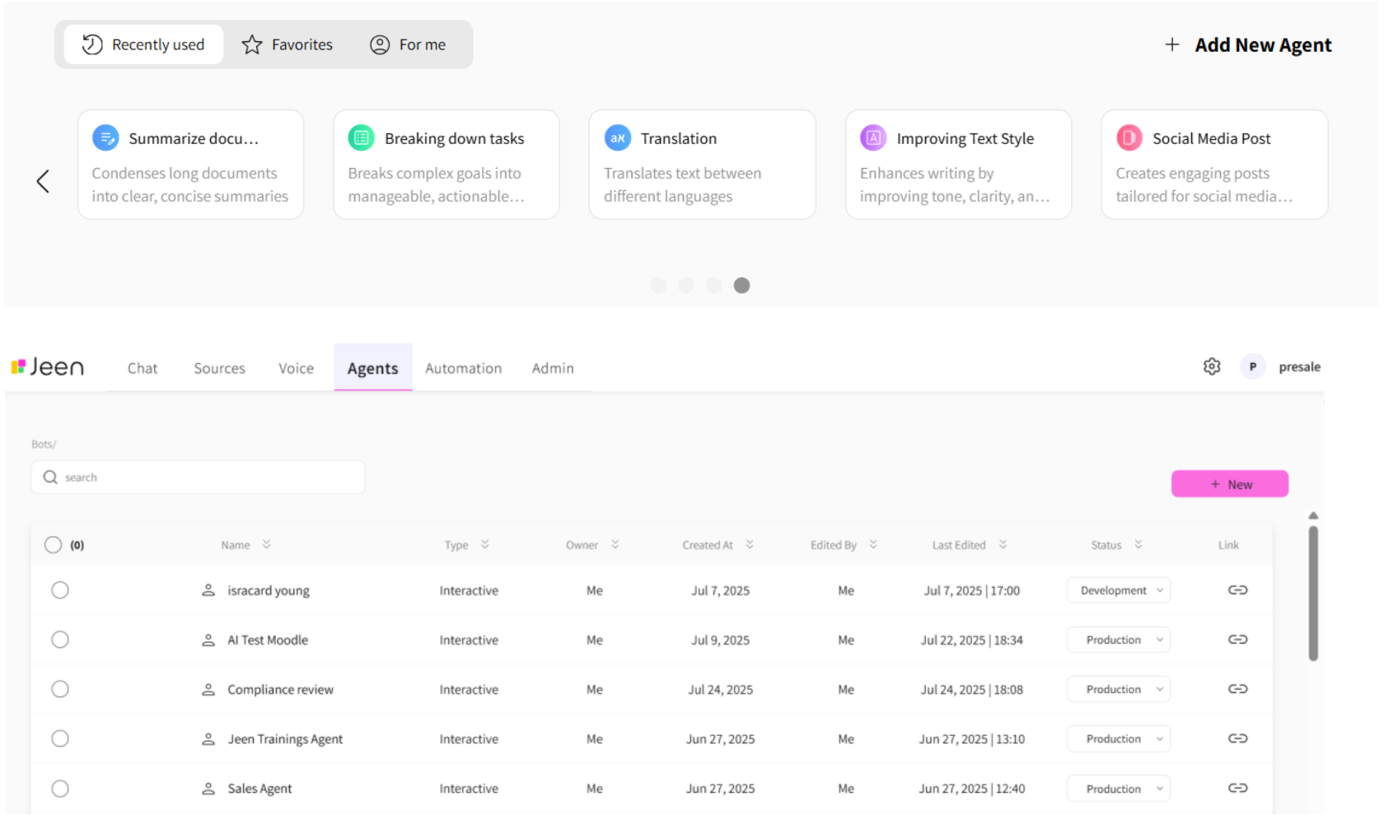

## 

## **Uploading and Processing Documents**

To create an agent, sometimes we want it to be based on organizational data.

To do this, we'll use the Sources tab.

The Sources tab serves as a library for documents that were uploaded manually or through a link to a knowledge management folder.

We'll typically use these documents in agents we create (detailed later).

### **Sources Tab Structure**

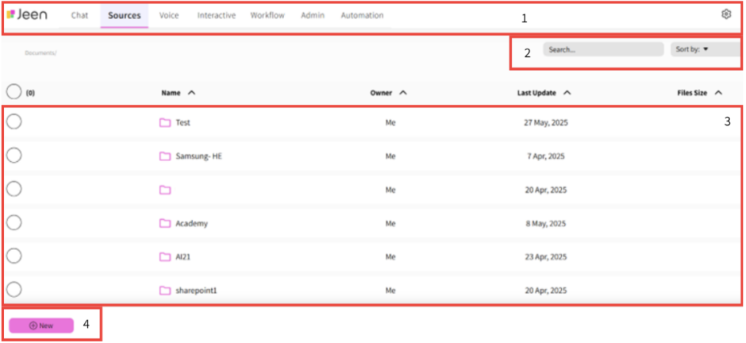

**Structure breakdown (numbered as in the image):**

1. **Top bar** - where we can see that we're in the Sources tab. On the right side of the bar, we can log out from the user.
2. **Document search and sorting** - we can sort documents alphabetically in Hebrew or ABC order. Additionally, we can search for a document or folder name using the search option.
3. **Sources list** - we can see the list of documents and folders. For each document and folder, we can see the date it was uploaded/created. By marking the circle on the left side, several options will appear at the bottom of the screen: download the document/all documents in the folder, edit the document/folder name, delete the document/folder, and more.



1. **Create folder or upload file** - to create a new document folder, click the New button and then Create Folder.

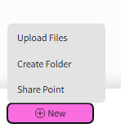

### **To upload a file:**

1. Click the New button
2. Click the Upload Files button
3. Select the documents you want to upload

, תמונה

1. Click the Submit button

While the document is uploading, a window will appear at the bottom where we can see the upload status of the document.  
When the document is uploaded, we'll see it together with all other documents in the Sources tab.